Here is a template for you to add your own story and links.
It’s a long blog, feel free to take out content that is not relevant to you.
Please ensure the blog includes The Big Swim logo and links to the event page.
We have included links and full URLs in case the links don’t copy across
---------------------------------------------------------------------------
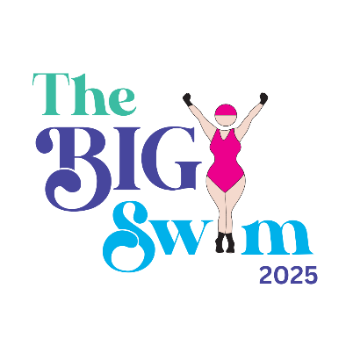
Why I’m Supporting The Big Swim 2025
The Big Swim 2025 will take place in two stunning locations: Brighton and Dorset, and is calling for 1,000 swimmers to take part in this extraordinary event. The swim is run in partnership with Land and Wave, Dorset and Sea Lanes, Brighton. Join me in creating the South Coast’s largest wild swimming gathering, celebrating International Women’s Day alongside a vibrant and supportive community.
For me/us (Edit), The Big Swim isn’t just about diving into cold water, it’s about connection, courage, empowerment, and creating something beautiful together.
I am supporting The Big Swim because (add content here) and because it really aligns with our values/what we stand for of (add content here)
Not only is this likely to be a record-breaking event in its own right, but it demonstrates just what we can achieve when we come together as a whole – supporting, celebrating and championing each other. This is the power of community.

A Celebration of Women
International Women’s Day is a moment to pause, reflect, and champion women from all backgrounds and locations. The Big Swim embodies that spirit by inviting people—women, families, friends, and even long-lost cousins—to come together in a vibrant display of solidarity.
This year’s theme, #AccelerateAction, reminds us that the fight for gender equity requires everyone’s efforts and contributions. By swimming, dipping, or even cheering from the sidelines, we’re showing support for women worldwide in a way that’s both meaningful and joyful. There is no place for ego at the waters edge, and there is no greater leveller than the sea.
To support my International Women’s day (IWD) I will be attending my local IWD Day event at (insert event title, date and location)

Uniting Through Wild Swimming
There’s something magical about the sea—the way it connects us to ourselves, to nature and to each other. Wild swimming has become my sanctuary, a place where I feel alive, free, and part of a larger community. The thought of gathering 1,000 swimmers across two stunning locations (Brighton and Sandbanks) to share in that experience is exhilarating.
I got into swimming because (add content here)

Taking Action for Women
The organizers of The Big Swim are asking the 1,000 swimmers to take one action to support and elevate women in their communities. Small actions can have a ripple effect, creating long-term, meaningful change that extends far beyond the day itself.
Here are a few examples of what you could do:
- Seek out and support businesses owned by women in your area, such as shops, restaurants, or service providers. Promote these businesses by leaving positive reviews and recommending them to all your friends.
- Volunteer at organizations that provide skills training or professional development for women and girls
- Join or support local organisations that work on issues affecting women, such as domestic violence shelters, reproductive health clinics, or education programs.
- Participate in community meetings, advocate for policies that promote gender equality, and amplify women's voices in decision-making processes.
- Everyone can take one action. Just pick one and make it happen!

The action I will be taking is (add content here)

Making Waves for a Cause
One of the reasons I’m so passionate about The Big Swim is its commitment to giving back. This event proudly supports Surfers Against Sewage, a charity dedicated to protecting our oceans from pollution and fighting for a sustainable future.
Over the last few years, I have not been able to swim because (add content here)

A Community Coming Together
The Big Swim is about more than just the swim itself—it’s a celebration of community, creativity, and connection. From the sparkly, colourful outfits we’re encouraged to wear to the group photo that will capture this unforgettable moment, it’s a chance to be part of something bigger than ourselves.
The event is also supported by incredible partners like PinkNicky’s Blog, Land and Wave, and many others who are dedicated to making this day safe, fun, and memorable.
Visit PinkNickys Blog and see her weekly updates https://pinknicky.com/blog/
Visit Land and Wave and check out their swim retreats https://landandwave.co.uk/

How You Can Join Me (add your name/business name here) at the Brighton/Dorset Dip delete as appropriate
Here’s how you can dive in and be part of the magic: Book Your Spot: Tickets go live on Monday, January 20th, 2025, and they sell out fast!
- Book your tickets here https://pinknicky.com/iwd-2025/
- Get Social: Follow PinkNicky #TheBigSwim on social media and invite your friends. https://www.instagram.com/pinknicky1/
- Get Social: Follow Land and Wave https://www.instagram.com/landandwave/
- Add content here - Add any relevant links to events/workshops on your website

A Personal Invitation
I’ll be there on March 8th, soaking up the atmosphere, cheering on swimmers, and maybe even braving the chilly waves myself. Whether you’re a seasoned swimmer, a curious newbie, or someone who just loves a good celebration, I’d love to see you there. There will be author talks, tea tasting and a whole lot of fun.
Let’s come together to make The Big Swim 2025 a day to remember—a day of laughter, support, and empowerment.
Follow me here and see me in action on the day (insert your social media link)
See you on the beach! 🌊
